Bedford County Public Schools
Wellness Policy Triennial Assessment
2017-2020

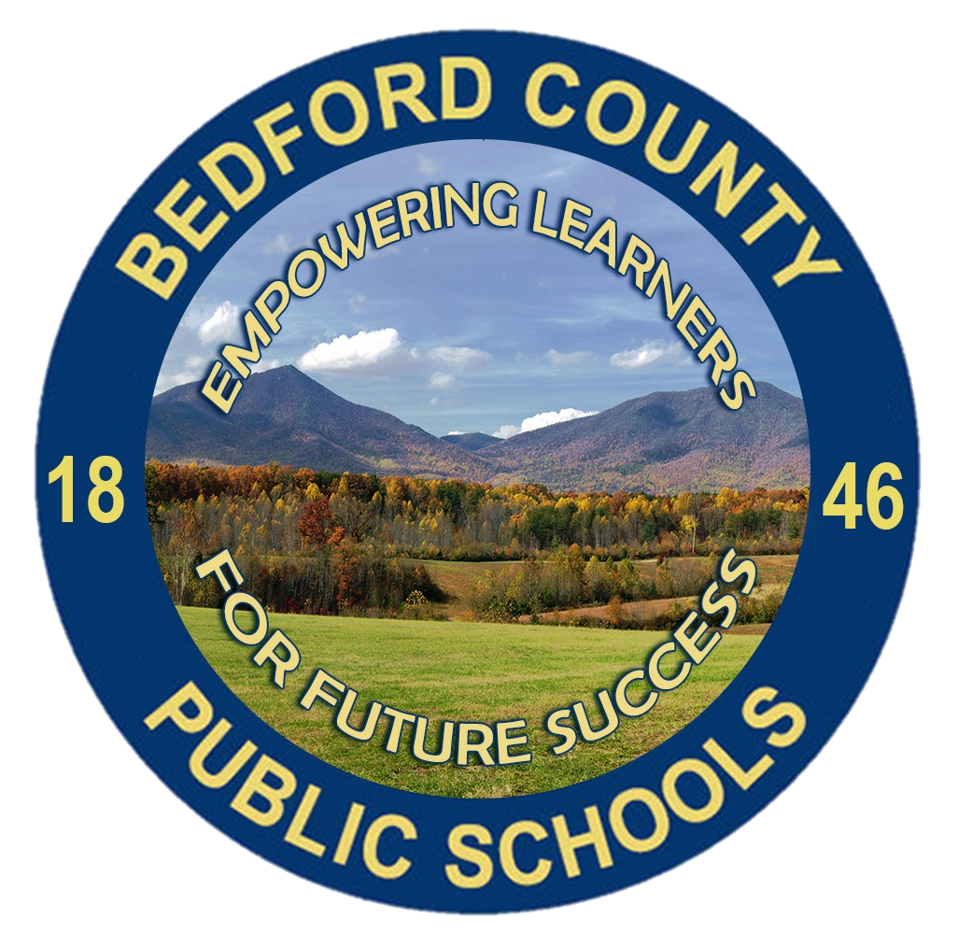

06/30/2021

Overview and Purpose
In accordance with the Final Rule of the Federal Healthy, Hunger Free Kids Act of 2010 and the Virginia Administrative Code: 8VAC20-740, Bedford County Public Schools (BCPS) presents the 2017-2020 Triennial Assessment which includes the timeframe from August 2017 through April 2020. The Triennial Assessment indicates updates on the progress and implementation of Bedford County Public Schools’ Wellness Policy and wellness initiatives, and provides required documentation of actions, steps, and information as outlined in the Final Rule. The school(s) included in this Triennial Assessment are: Bedford Primary/Elementary Schools, Big Island Elementary School, Boonsboro Elementary School, Forest Elementary School, Goodview Elementary School, Huddleston Elementary School, Moneta Elementary School, Montvale Elementary School, New London Academy, Otter River Elementary School, Stewartsville Elementary School, Thomas Jefferson Elementary School, Forest Middle School, Liberty Middle School, Staunton River Middle School, Jefferson Forest High School, Liberty High School and Staunton River High School. Bedford County Public Schools also operates two additional full-time programs through the Susie G. Gibson Science and Technology Center and the Alternative Education Center. These programs do not maintain operational food service to students and rely on partner schools if lunches are provided on site.

Wellness Policy
The Bedford County Public Schools Student Wellness Policy can be found here under Policy JHCF on the BoardDocs section of the website. The division updates or modifies the policy as appropriate with the current policy approved on May 10, 2018. The original policy was adopted July 10, 2006.

Authority and Leadership
Bedford County Public Schools are committed to a shared responsibility for creating a climate and culture that emphasizes the wellness of the whole child, including promotion of good nutrition and physical activity. In order to promote academic and personal success experiences for learners, every aspect of the school experience should promote a positive, safe, secure and health-promoting learning environment. Broad oversight of the Wellness Policy begins with the School Health Advisory Board (SHAB) with direct responsibilities overseen by the Supervisor of Health and Supervisor of School Nutrition. In accordance with the Final Rule, the Director of Student Support Services serves as the specific designee identified to help lead the oversight, implementation and progress assessments of the wellness policy and its requirements.
For the purpose of this Triennial Assessment, the designated official is the Director of Student Support Services.

School Health Advisory Board
The School Health Advisory Board (SHAB) meets at least two times per year to oversee school health and safety policies and programs, including periodic review of the district wellness policy.
SHAB meetings are coordinated by the Supervisor of Health and include a variety of key stakeholders in the realm of student wellness. Current membership includes both the Supervisor of Health and Supervisor of School Nutrition. SHAB also has standing membership to include parents and PTA representatives, school administrators, school psychologists, school counselors, local Virginia Cooperative Extension staff, local hospital staff and representation from the Bedford Community Health Foundation.
Each SHAB meeting provides an advance agenda with the invitation for any team member to add requested information to the agenda. The team has the benefit of partnership with our local hospital to access the results of the Bedford Community Health Needs Assessment conducted by CentraHealth which allows the SHAB to align goal setting with broader community needs.

School Nutrition Program
Bedford County Public Schools currently participates in the National School Lunch Program (NSLP), School Breakfast Program (SBP), Afterschool Snack Program (ASP) and Summer Food Service Program (SFSP). BCPS has increased the Community Eligibility Partnership to serve 1 school in 2019, 2 schools in 2020 and 8 schools in 2021.
BCPS has increased the total percentage of free and reduced lunch eligibility over the last three years with 2020 showing a 33.93% for free lunch and 6.23% for reduced lunch for a total 40.17% of eligible students. The 2019 Administrative Report summarized the following participation rates:
 | Average daily participation | Lunch: Average daily participation | Breakfast: Average daily participation
Free lunch students | 2169 | 49.37% | 63.38%
Reduced lunch students | 398 | 9.06% | 10.9%
Paid lunch students | 1826 | 41.57% | 25.72%
The 2019 Administrative Report noted one finding for an eligibility calculation error with no findings for verification and meal counting/claiming. Meal components and quantities, offer versus serve and dietary specifications and nutrient analysis were all in compliance. There were also no findings of concern for food safety, the BCPS Wellness Policy, competitive food sales and civil rights compliance.

Wellness Policy Compliance
Bedford County Public Schools must conduct an assessment of the Wellness Policy every three years, at a minimum. The final rule requires State Agencies to assess compliance with the Wellness Policy requirements as a part of the general areas of the Administrative Review every three years.
Standards and Nutrition Guidelines for all Foods and Beverages Sold
(Question IV on VDOE School Level Report Card)
Standard/Guideline | Met | Not Met
We follow federal school meal nutrition standards for all foods and beverages available for sale on campus during the school day. | Fully in Place
We have implemented Smart Snacks nutrition standards for ALL items sold during school hours, including: a la carte offerings, items in school stores, and items in vending machines. | Fully in Place
We follow Bedford County Public Schools’ policy on exempt fundraisers as outlined in our Division’s Wellness Policy. | Fully In Place

Standards and Nutrition Guidelines for all Foods and Beverages Sold
(Question V on VDOE School Level Report Card)
Standard/Guideline | Met | Not Met
We follow Bedford County Public Schools’ policy on standards for all foods and beverages provided, but not sold, as outlined in our Division’s Wellness Policy.  - Administrative compliance and guidelines are communicated to each school site and staff member. There have been inconsistent applications by individual teachers/staff but those instances are addressed with administrative guidance on policy requirements and regular policy monitoring. | Fully in Place
Policy for Food and Beverage Marketing
(Question VI on VDOE School Level Report Card)
Standard/Guideline | Met | Not Met
All food and beverage marketing meets Smart Snacks standards. | Fully in Place

Description of Public Involvement
Standard/Guideline | Met | Not Met
Bedford County Public School permits participation by the general public and the school community in the Wellness Policy process. This includes parents, students, and representatives of the School Food Authority, teachers of physical education, school health professionals, the School Board, and school administrators. | Fully in place

Description of Public Updates
Standard/Guideline | Met | Not Met
The Wellness Policy is made available to the public on an annual basis, at minimum. This includes any updates to and about the Wellness Policy. | Fully in place
The Triennial Assessment, including progress toward meeting the goals of the policy, will be made available to the public on or before June 30, 2021. | Fully in place

Description of Policy Leadership
Standard/Guideline | Met | Not Met
Bedford County Public Schools established a Wellness Policy leadership of one or more LEA’s and/or school official(s) who have the authority and responsibility to ensure each school complies with the policy. | Fully in place

Description of Evaluation Plan
Standard/Guideline | Met | Not Met
Each year, the Supervisor of Health collects an End-of-Year status report on the Wellness Policy. Each school completed a self-assessment using the Triennial Assessment Template provided by Virginia Department of Education. | Fully in Place

Wellness Policy Review
Thoroughly reviewed by USDA Food and Nutrition Service, the Alliance for a Healthier Generation’s model policy template is in compliance with the requirements set forth in the final rule. BCPS Policy JHCF identifies key elements that align with the Alliance for Healthier Generation Ten Essential Components of a Local School Wellness Policy checklist.
Policy JHCF identifies appropriate school official(s) who have the authority for ensuring compliance with the policy.
Policy JHCF includes language inviting input and participation of stakeholders in the review and update of the Wellness Policy and provides for notice of policy content.
Policy JHCF identifies a process for the triennial progress assessment and to report on progress towards attainment of goals of the Wellness Policy.
Policy JHCF does identify the nutritional guidelines required of the school nutrition program and extends guidance to the nutritional content of foods/beverages used for celebrations or for items provided but not sold to students. Celebrations for classrooms (using food/beverage products) are limited to three per year. A healthy snack list is provided for all schools to utilize for the provision of food items outside of the school nutrition program.
Policy JHCF stipulates the provision of a physical fitness and activity program for 150 minutes per week to include the combination of physical education classes, recess, elective courses, extracurricular programs and school-based fitness or wellness clubs.
Policy JHCF does address the promotion of hydrations by making water available to all students throughout the school day, including mealtimes. Students are permitted and encouraged to carry refillable water bottles.
Policy JHCF includes United States Department of Agriculture (USDA) guidance for Smart Snacks in school nutrition and requirements for marketing. The policy also provides USDA guidance for school-based fundraisers to address foods not intended for consumption at school.
Policy JHCF provides for nutrition promotion and education through cooperative efforts with nutrition staff, school nurses and other school personnel.
Specific goals relating to student wellness are identified in the division’s Strategic Plan for Student Wellness rather than the Wellness Policy.

Progress towards Goals
BCPS has made progress towards the Wellness Policy goals and schools identified several specific areas of growth over the three year period. Schools reported individual wellness activities, including:
- Increased community awareness of healthy food items for bring-in celebrations
- Breakfast week promotions
- Limitation of celebrations with bring-in food
- Alternative fund-raisers with emphasis on physical activity (e.g. Jump Rope for Heart, Fun Run)
- Parent-Teacher Association Family Fitness Night events
- Rev your Bev days throughout the division
- Walking Clubs offered before school
- Fitness-based Clubs for school club days or after school (e.g. Girls on the Run)
- Increased course offerings for middle/high school students to increase access to physical activity courses (PE Electives, Personal Fitness, Strength and Conditioning)
- Maintaining open gym periods
- Physical Education course enhancements (personal fitness logs, guest instructors, Healthy Heart Curriculum, Presidential Fitness program)
- Incorporation of sensory and movement breaks into classroom activities (i.e. Go Noodle, Get Ready to Learn)
- Transformation of hallspaces into sensory walks or utilization of sensory rooms
- Individual school partnerships with Cooperative Extension for farm to table produce sharing
Progress towards Nutrition Promotion and Education Goals
(Question I on VDOE School Level Report Card)
Description | Met | Not Met
Students receive nutrition education that teaches the skills needed to adopt and maintain healthy eating behaviors. Nutrition education is provided cooperatively by the school nutrition staff, school nurse and classroom teachers. | Fully in place
Health and science (elementary) education curriculum addresses required components of nutrition and physical wellness. Staff who provide nutrition education have appropriate training. | Fully in place

Progress towards Physical Activity Goals
(Question II on VDOE School Level Report Card)
Description | Met | Not Met
BCPS provides a physical fitness program that includes at least 150 minutes per week on average during the regular school year. This may include any combination of physical education courses, recess or extra-curricular programs. | Fully in place
Students have opportunities for physical activities through a range of before/after school programs. |  | Partially in place 16/19
Schools work with the community to promote physical activity, be active role models and include physical activity in family events. |  | Partially in place 17/19

Some schools reported limitations to the before/after school programs based on resource limitations in the immediate area. Several schools identified Family Fitness/Wellness events or programs but not as comprehensive programs. One item on the community partnership includes the capacity and encouragement for students to walk/bike to school. While this goal is reflected in policy JHCF, please note that many BCPS schools would not have appropriate locations for students to travel to/from school other than by car.
Progress towards other School-Based Wellness Activity Goals
(Question III on VDOE School Level Report Card)
Description | Met | In progress/Not Met
Expansion of cart-delivery or grab-and-go school nutrition programs to each school to increase meal consumers at breakfast.  - Since 2017, BCPS has expanded breakfast carts or grab-and-go breakfast to 7 schools. | Met
Expansion of Community Eligibility Provisions (CEP) status for school-wide meal provision.  - BCPS increased from 0 schools participating in CEP in 2018 to 8 CEP schools in 2021. | Met
Develop SNAP-Ed partnerships to assist elementary students (with 50% or more Free and Reduced Lunch) with healthy food consumption and reduction of food waste through nutrition education. SNAP-Ed also provides training for teachers to incorporate more physical activity or mindfulness into their classroom.  - Five elementary schools are currently eligible for a SNAP-Ed partnership and BCPS would like to have formalized relationships with Virginia Cooperative Extension for two elementary schools by the conclusion of the 2021-2022 school year. |  | Not Met
Full implementation of InDepth partnership with the Virginia Department of Health (VDH).  - VDH will renew a partnership with BCPS to provide tobacco cessation education at each middle/high school campus for any students experiencing a tobacco violation. | Met
Develop partnership with Horizon Behavioral Health to identify outpatient treatment programs within middle/high school facilities.  - Horizon Behavioral Health has partnerships with each middle/high school campus for the provision of out-patient counseling and case management. | Met
Each school counseling program will introduce and provide self-regulation/mindfulness practices and spaces that promote calm learning states and are accessible through student and teacher agency. |  | In Progress
Encourage and equip schools to explore school-wide, embedded social-emotional learning programs. |  | In Progress
Expand the role of the site-based Mental Health Support Team for the provision of faculty training or facilitated learning | Met/  Ongoing
Specific questions about the Wellness Policy Triennial Assessment may be directed to the Supervisor of Health or the Director of Student Support Services.

